Faculty of Computing



Database Systems Lab Manual # 02

Sitara Rehman

Sap ID:66454

**TASK#1**

1. Library Management System Scenario: A library has many books, and each book belongs to exactly one category. A member can reserve zero or many books, but a book can be reserved by zero or many members. Each book can be borrowed by exactly one member at a time, but a member can borrow one or many books. The library also tracks loan and return dates. • Draw an ERD for Members, Books, Categories, Loans, and Reservations. • Identify Primary keys, foreign keys. • Define the relationships, specifying cardinality.

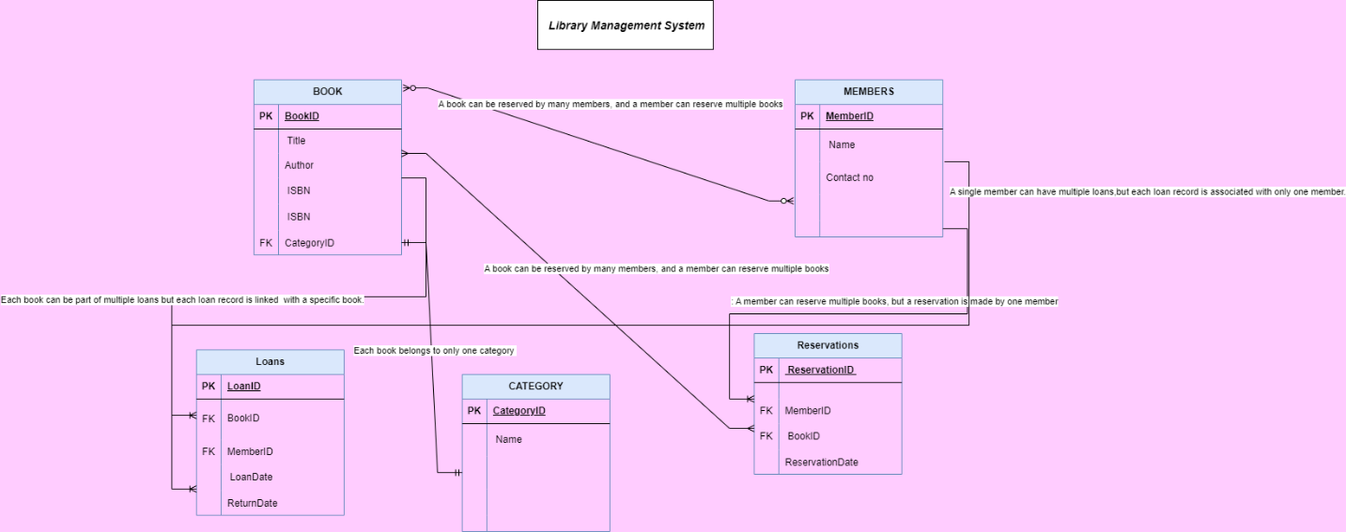

Task#2

Online Shopping Platform Scenario: On an e-commerce platform, each product can belong to one or many categories, and each category can contain zero or many 8 products. Customers can place one or many orders, and each order can include one or many products. Products are supplied by one or many suppliers, and a supplier provides one or many products. • Create an ERD for Products, Categories, Orders, Customers, Suppliers. • Specify PK,FK and cardinality relationships

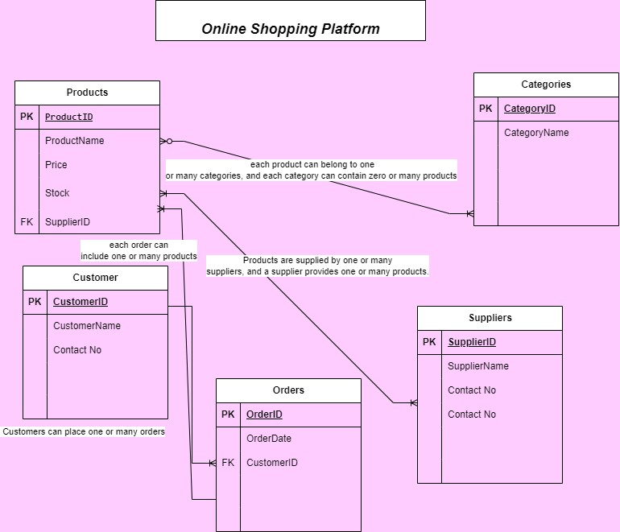

TASK#3

3. University Course Registration System Scenario: A student can register for one or many courses, and each course can have one or many students. Each course is taught by one professor, but a professor can teach zero or many courses. Every student is assigned to exactly one advisor, and each advisor can advise one or many students. The university tracks grades for each student in each course. • Create an ERD showing the relationships between Students, Courses, Professors, Advisors, and Grades. • Define the relationships, specifying cardinality constraints

